**Deep Generative Modeling**

*Take input sample data from some distribution and learn a model that represents the underlying distribution*.

For example, from the given sample points from an unknown distribution:   
  
We can generate the underlying distribution that created that sample:



Latent Variables:

Variables which are not directly observed but are rather inferred through a mathematical model, which we assume to have generated our actual training data.

All types of generative models aim at learning the true data distribution of the training set so as to generate new data points with some variations. But it is not always possible to learn the exact distribution of our data either implicitly or explicitly and so we try to model a distribution which is as similar as possible to the true data distribution. So, we use power of NNs to produce these models. The main approaches are:

* AutoEncoders (VAE)
* Generative Adversarial Networks (GAN)

**Variational AutoEncoders:**

VAE is one of the most popular approach to learn the complicated data distribution such as images using neural networks in an *unsupervised* fashion. We actually give a probabilistic spin to standard AEs in VAE. This model aims to learn the underlying probability distribution of the training data so that it could easily sample new data from that learned distribution. The latent variables can store useful information about the type of output the model needs to generate. And then later decode the image (or input data) from the latent variables. The best thing of VAE is that it learns both the generative model and an inference model.



**Generative Adversarial Networks:**

Adversarial training has completely changed the way we teach the neural networks to do a specific task. Generative Adversarial Networks don’t work with any explicit density estimation like Variational AutoEncoders. Instead, there are two neural networks i.e. a ***generator*** and a ***discriminator.***



Basically, the task of the Generator is to generate natural looking images and the task of the Discriminator is to decide whether the image is fake or real. This can be thought of as a mini-max two player game where the performance of both the networks improves over time. In this game, the generator tries to fool the discriminator by generating real images as far as possible and the generator tries to not get fooled by the discriminator by improving its discriminative capability. The above image shows the basic architecture of GAN.

**Can you find what’s wrong with the image below?**

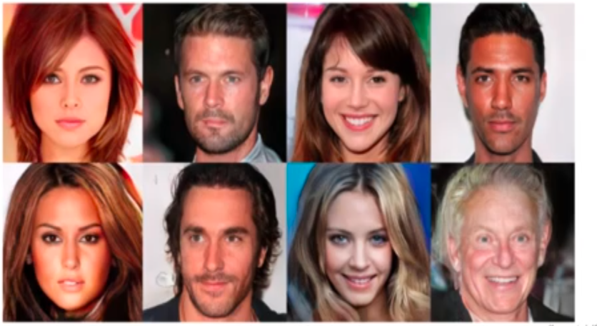

***Believe it or not these are fake images produced by a GAN. How cool is that??***